Guidance for teachers on how OpenStudio can be used

OpenStudio is a course activity that allows students to share images, files and other media; it can be shared within groups, or used as an individual's work portfolio. OpenStudio is a creative, collaborative space for students to work as if they are physically in a design studio, sharing their work with tutors and other students and getting feedback on it, and commenting other people's work.

**Tips for using OpenStudio**

Although Open Studio provides a very user-friendly interface, students who have never come across a similar platform will need some time and guidance for how to use the platform effectively. Make sure you provide space and advice well in advance of any important activities or assessments which require the use of OpenStudio.

Because OpenStudio makes it very easy to share found content with others, it offers an important opportunity for teaching students about concepts such as copyright, creative commons, attribution, etc.

Given that the use of OpenStudio involves a small learning curve for students, it pays off to integrate the use of OpenStudio throughout a course rather than only having one or a few activities using it at the beginning or the end. This way, students don’t feel like they have to learn a technology just for a few small parts of the course.

Where configures accordingly, OpenStudio allows students to decide the access settings for material they upload – i.e., who will be able to see their uploads. It is important to make students aware of these settings so that they can decide what they feel comfortable sharing with other students inside and outside of their groups.

As that OpenStudio allows students to comment on each other’s work and provide feedback, it is important to develop some useful skills here around providing and receiving feedback effectively to avoid situations where students give each other inappropriate feedback or feel attacked by the feedback provided by others

Guidance from GitHub

Documentation

Once you have decided that OpenStudio is a tool you would like to incorporate into your course, you can choose how to configure your studio to suit your needs.

Edit Settings

General

**Name and Description:** These are both required before you can create the OpenStudio. The title should be short and accurate, and the description should clearly explain what the OpenStudio will be used for.

Theme

You can change the themes in OpenStudio. Be aware though, that the user guidance will still refer to the default name settings and may make it difficult for students to refer to the ‘user guide’.

**Your word for...**: You can change the names of the 'My Module', 'My Group', 'My Studio Work' and 'My Pinboard' tabs by entering your desired terms in these fields.

Common Module Settings

Availability

you can decide whether students can see the studio on their course page.

Show on course page: Means that students can see and access OpenStudio.

Hide from students: You can decide to hide OpenStudio from students until a particular time. This can be useful if you are giving students access to pre course material for example but don’t want them to access other areas.

ID number: Add an ID number for the studio; provides a way of identifying the activity for grade calculation purposes. If the activity is not included in any grade calculation then the ID number field may be left blank.

**Group mode** and **Grouping:** Use these settings to restrict the OpenStudio to 'Separate groups' and 'Visible groups'. Once the activity is grouped, you can choose to restrict the activity to a specific grouping. The options within the 'Grouping' drop-down menu will be specific to the course you are on. By default the 'Group mode' is set to 'No groups' and 'Grouping' is set to 'None'.

Restrict Access

You can choose to set various restrictions for your studio. These features can really help you to restrict when and how students use OpenStudio. For example, you can specify that students must complete certain activities before accessing OpenStudio, add specific dates that OpenStudio will become available / unavailable or specify the groups of students that can access it. If you would like to add restrictions, click on the ‘add restriction…’ option for more details.

Activity Completion

Completion tracking: This will allow students to mark the OpenStudio activities as complete within their study pages. If it is set to manual, they will need to check the tick box themselves.

Expect completed on: You can specify within their study pages when the activities should be completed by. This date is not shown to students, even if it has been enabled (by default this is left blank).

Social settings

Sharing work with other students can be extremely beneficial. You can decide what can be shared within OpenStudio to suit your course. Alternatively, OpenStudio can be used as personal ‘cloud’ storage for students to organise their own work if no sharing options are enabled.

**Sharing level** sets how widely students can share their work. Setting an OpenStudio instance to 'Private' and 'Group' means your default sharing level is limited to the same settings.

Private - only the owner can see it

Group - visible to group members

Module - visible to all course members

Tutor - only the student and their tutor can see it (The student and 'tutor' should reside in the same group - module should also use a 'Grouping' for this feature to work)

**Sharing default**: This sets the default when the student creates work in OpenStudio. The options you are presented with depend on the 'Allowed sharing level'.

Private - only the owner can see it

Group - visible to group members

Module - visible to all course members

Tutor - visible only to the student and their tutor

**'Tutor' roles** Tick the roles who will be able to see slots that students share with 'My tutor'.

(The student and user with 'tutor' roles should reside in the same group. The common module settings for 'Grouping' should be set for this feature to work)

**Flags** Use these to specify the flags you want students to be able to use. Flags enable students to give feedback without having to add any text.

Flags that students can add to posts:

’Favourite’,  ‘smile’ and ’inspired’.

Comment flags: Students are able to ‘like’  other student’s comments if this option is selected here.

Custom features

**Enable 'My Module'**: This is a default feature of OpenStudio - untick it to disable this tab. My Module means that students can choose to share their posts from their Pinboard with the whole module if they wish. This will also depend on the settings you have chosen within the ‘sharing options’.

**Enable pinboard**: The pinboard is the students’ personal upload area. Students can keep their posts private or can choose to share their posts. This specifies the number of pinboard slots that students can upload. Entering '0' disables the feature.

**Enable versioning**: Versioning is a useful feature within OpenStudio that allows students to show development in their work. It is only applicable to slots within the ‘My Activities’ area. If this is enabled, students can, for example, upload a piece of work, gather feedback, and upload subsequent versions showing how they have used feedback to improve their work. Use this to specify the number of versions students can upload for each slot. If students upload more than the number of allowed versions, the oldest version is disabled. If you would like to delete versioning, enter '0'.

**Content comment uses audio attachment**: Ticking this enables students to add audio attachments instead of writing comments in slots or writing descriptions, particularly useful for students that may find it easier to provide verbal feedback / comments rather than written ones. This doesn’t mean that students won’t also be able to add written comments.

**Content allows file uploads**: Tick these to allow students to add file uploads to slots. This will give your students a wide scope of the types of work that they can submit on your course.

**Content allows notebook files:** This allows the upload of .nbk archives containing ipython notebooks to posts. By default this is disabled.

**Enable content reciprocal access** This stops students from viewing other student's slots before they have uploaded and shared theirs. By default, this is disabled. It can be used as a way to encourage students to complete activities and share with their peers.

**Show Participation smiley** Tick this to show the participation smiley by the progress bar according to the students’ level of participations. By default, this is disabled. If the student has uploaded more work than comments they have added to other students’ work, a ‘sad face’ will be displayed. It can be a way to encourage students to interact with their peers.

**Enable folders**: Folders are groups of slots that you can upload to OpenStudio that contain related content. Folders allow students to upload new content (slots) so it is grouped together. By default, this is disabled . This is useful for project work requiring more than one piece of work / evidence, for example.

**Add any content to folders**: This allows users to add other users’ slots to their sets. This is not default and needs to be enabled if students are required to collect other people’s slots as part of their work.

**Abuse reports are emailed to**: Not supported.

Allow late submissions: This is relevant for ‘My Activities’. If enabled, this allows users to upload post content beyond a set submission date or date the slot will be locked. This is not enabled by default.

Warning message for late submissions: This is the message that displays on a post when the submission date has passed. The placeholder '%%DATE%%' will be replaced by the submission date. This field is only enabled if 'Allow late submissions' is selected.

Upload settings

The following file types can be uploaded to OpenStudio:

Images: jpg, jpe, jpeg, gif, png

Videos: avi, mpg, mov, mp4, m4v, flv, gif

Audio: aiff, wav, mp3, m4a

Documents: doc, docx, rtf, pdf, odt, txt, nbk

Slides: ppt, pptx, odp, pdf

Spreadsheets: xls, xlsx, csv, ods

2D/3D drawings: dwg, dxf, skp, stl, stp, svg, eps

Zip files.

**Maximum file size**: This sets the maximum file upload size and is a subset of the course upload limit

Configuring structure

You can set structured activities for students under the ‘Manage Levels’ heading in the Administration drop down menu.

Structure

OpenStudio uses a straightforward hierarchy of: [Block] -> [Activity] -> [Slot]

This means that you need to set up your blocks, then enter each block and set up your activities, then enter each activity and set up each slot. You can rename blocks, activities and slots as you need for your course,

e.g.: Design in your home -> Your favourite designs -> Circular shapes Learning Guide 2 -> Reflecting on your learning -> My response

Blocks

[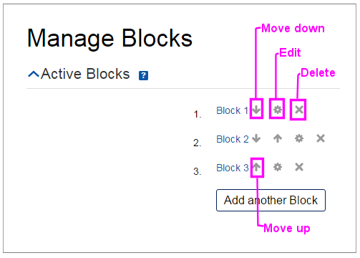](https://github.com/moodleou/moodle-mod_openstudio/blob/master/internaldoc/openstudio_admin_manage_blocks.png)

**Block set-up** Use Add block/Add another block to create blocks. Use the up/down arrows, Edit or Delete buttons to set out your block hierarchy.

Use the up/down arrows and the delete icons to set out your block hierarchy.

Use the edit icons to change block names should you need to, click Save Changes to confirm any changes you make to block names.

Selecting View Contents next to a block title searches the OpenStudio with the title of that block.

To view the activities within a block, select the block name.

Activities

[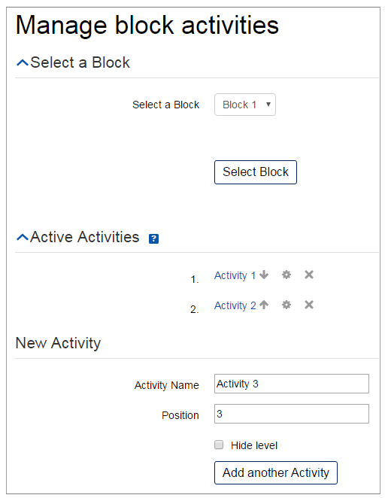](https://github.com/moodleou/moodle-mod_openstudio/blob/master/internaldoc/openstudio_admin_manage_activities.png)

**Activity set-up** After setting up the blocks, create the activities for each block. Click Activities under Manage levels in the administration block. Select a block from the drop-down menu and click on the Select block button. Then click Add another activity and enter a name and position in the fields that appear. You can use the block drop-down menu to change blocks (remember to click Select Block after selection). You can hide the activity level by ticking the box next to the activity.

Slots and sets

[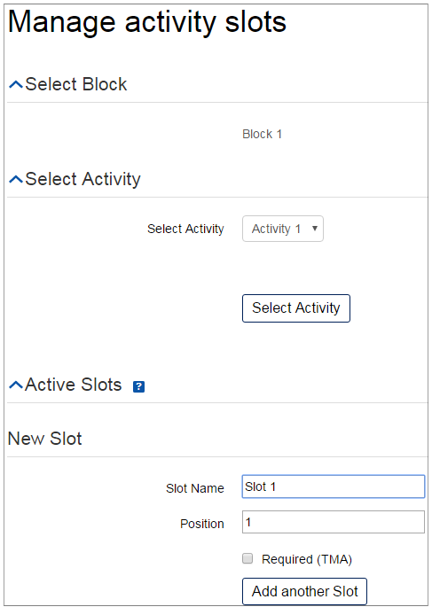](https://github.com/moodleou/moodle-mod_openstudio/blob/master/internaldoc/openstudio_admin_manage_slots.png)

Slots

Finally, add slots to each activity. You can change the activity you are adding slots to by using the activity drop-down menu and then click Select activity. Enter the name of the slot, the position of the slot in the activity and tick the Required (TMA) box if it is required.

Tick the Is folder? box to create a folder rather than a slot.

**My Pinboard**

If 'My Pinboard' is made available to students, they create their own slots.

Sets

Folders allow students to create a collection of slots. Slots created specifically for folders cannot be found outside the folder. To allow students to create folders, make sure you have selected Enable folders from 'Custom features' in the 'Edit settings' menu.

Pre-configured folders appear on the My Studio Work tab. To add slots and activity guidance to the set, click on the set's hyperlink. This opens a configuration window.

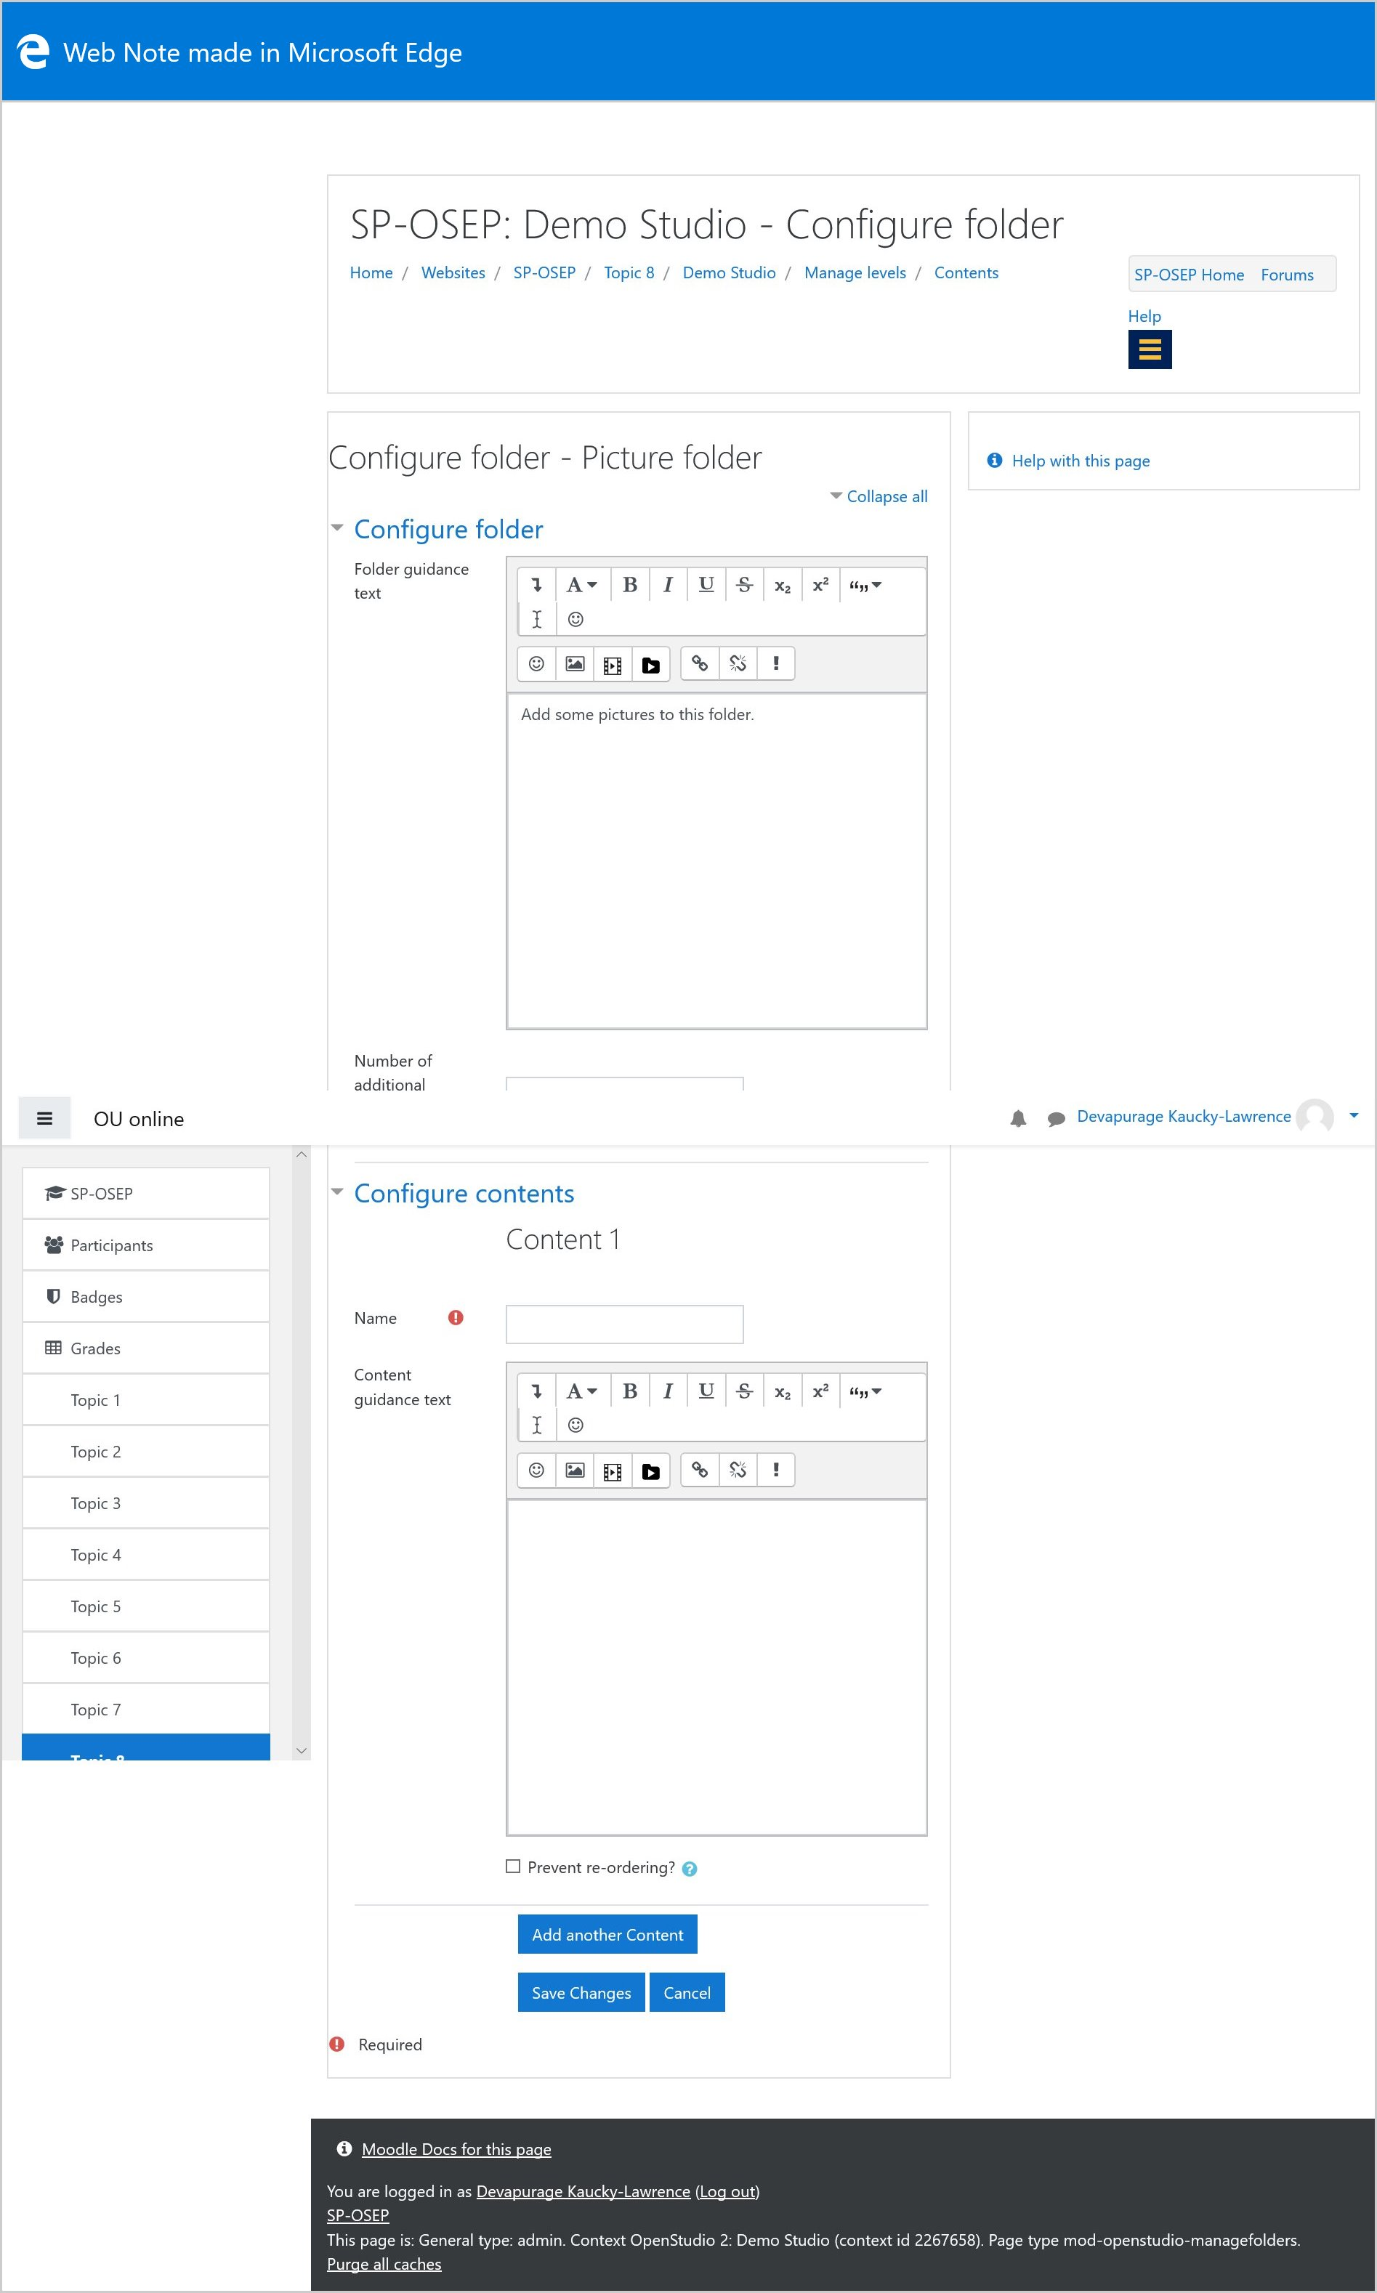

Use this screen to add:

activity guidance (rich HTML)

the number of additional slots that can be added (0 by default), in addition to those pre-configured

a number of pre-configured slots (none by default), specifying:

the slot title (text)

slot guidance

whether the user is permitted to re-order the slot within the set.

If folders have not been pre-configured, students can add them from their My Pinboard tab.

**'Required' slots/folders**

Some slots can be flagged as 'Required' to OpenStudio users. This adds 'Required' to the slot name and changes the slot background colour to grey instead of the normal white. Set the option within the slot editing options by ticking the Required (TMA) box.

Locked folders/slots

To enable folder/slot locking, make sure you have ticked Enable 'Locking' in the 'Custom features' setting.

Pre-configured locking of folders/slots

Once the slot or set has been created on the 'Manage levels' page, click on the 'edit settings' icon to open the locking options.

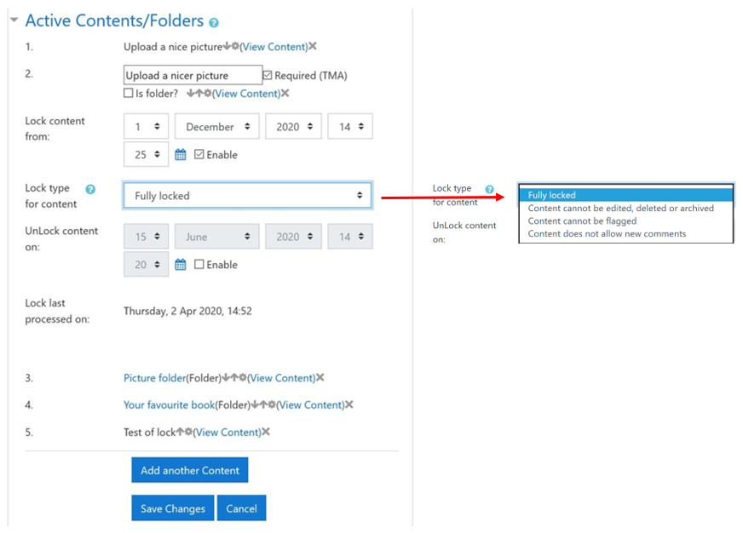

There are different levels of locking possible from the 'Lock type' drop-down menu. These are:

Fully locked

Slot cannot be edited, deleted or archived

Slot cannot be flagged

Slot does not allow new comments.

You can also lock and unlock folders and slots using the date and time fields on this page.

Students cannot manually lock slots/folders themselves, so if assessment and locking are required in OpenStudio the preconfiguring of slots/folders should be used and auto locking applied – this will need to be made clear in activity guidance.

**Unlocking pre-configured slots that have been locked**

If, for example, a slot has been set up to lock on a pre-defined date but a student is then granted an extension, it is possible to unlock it for that student. To do this:

Navigate to the 'My module' tab.

Click on the 'people view' thumbnail.

Find the student in the list. Click View [name of student]'s work.

In the 'Progress' area, the tile for the empty locked slot is marked red. Click on it.

In the box that appears, click Yes.

Once unlocked, it is then possible to then manually lock that user's slot (see below).

Manual locking/unlocking of slots

To manually lock sets or slots, navigate to the bottom of the set or slot that you would like to lock or unlock. Click Lock or Unlock.